EXERCISE CAHPTER 3

LEVEL 1

A)

/****************************************************************/

/* The INFILE statement uses a Microsoft Windows path. */

/* */

/* For UNIX, Linux, SAS University Edition, and SAS on Demand: */

/* Change the INFILE statement to: */

/* infile "&path/donation.dat" dlm=','; */

/* */

/* For z/OS: */

/* Change the INFILE statement to: */

/* infile "&path..rawdata(donation)" dlm=','; */

/****************************************************************/

**data** work.donations;

infile "&path\donation.dat";

input Employee_ID Qtr1 Qtr2 Qtr3 Qtr4;

Total=sum(Qtr1,Qtr2,Qtr3,Qtr4);

**run**;

**proc** **contents** data=work.donations;

**run**;

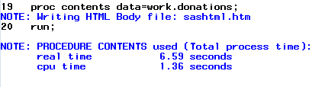

b)

**proc** **print** data=work.donations;

**run**;

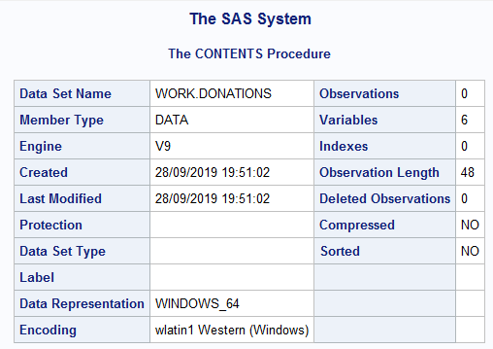

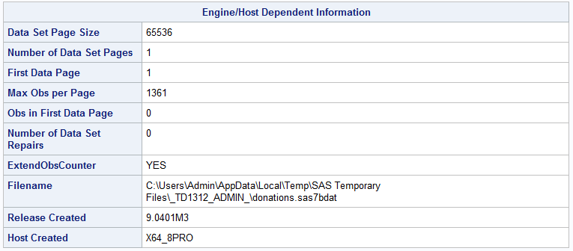

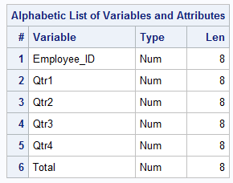

c) LIBNAME ORION"C:\Users\Admin\Desktop\SAS\P1 DATA & PROG\P1 DATA";

**proc** **contents** data=orion.donaton;

**run**;

**proc** **print** data=orion.donation;

**run**;

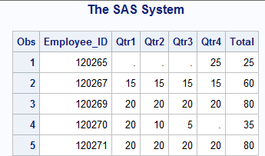

LEVEL 2

2.

**data** work.newpacks;

input Supplier_Name $ **1**-**20** Supplier_Country $ **23**-**24**

Product_Name $ **28**-**70**;

datalines;

Top Sports DK Black/Black

Top Sports DK X-Large Bottlegreen/Black

Top Sports DK Comanche Women's 6000 Q Backpack. Bark

Miller Trading Inc US Expedition Camp Duffle Medium Backpack

Toto Outdoor Gear AU Feelgood 55-75 Litre Black Women's Backpack

Toto Outdoor Gear AU Jaguar 50-75 Liter Blue Women's Backpack

Top Sports DK Medium Black/Bark Backpack

Top Sports DK Medium Gold Black/Gold Backpack

Top Sports DK Medium Olive Olive/Black Backpack

Toto Outdoor Gear AU Trekker 65 Royal Men's Backpack

Top Sports DK Victor Grey/Olive Women's Backpack

Luna sastreria S.A. ES Hammock Sports Bag

Miller Trading Inc US Sioux Men's Backpack 26 Litre.

;

**run**;

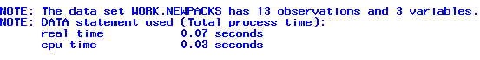

B)

**PROC** **CONTENTS** DATA=WORK.NEWPACKS;

**RUN**;

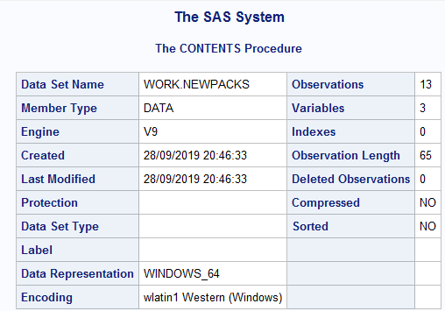

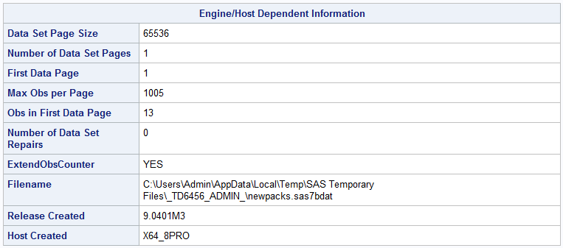

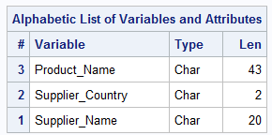

C) 13 OBSERVATIONS

3 VARIABLE

SIZE LENGTH FOR PRODUCT_NAME=43

D) **PROC** **PRINTS** DATA=WORK.NEWPACKS;

**RUN**;

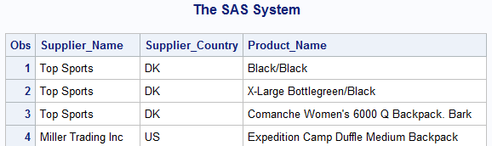

CHALLENGE

1. WORKING WITH TIMES AND DATETIMES

a)

**data** work.date;

CurrentDate=today();

CurrentTime=time();

CurrentDateTime=datetime();

**run**;

**proc** **print** data=work.date;

**run**;

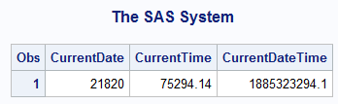

b) current time=75294.14

current date time=1885323294.1

c)sas help on how times and datetimes stored in sas

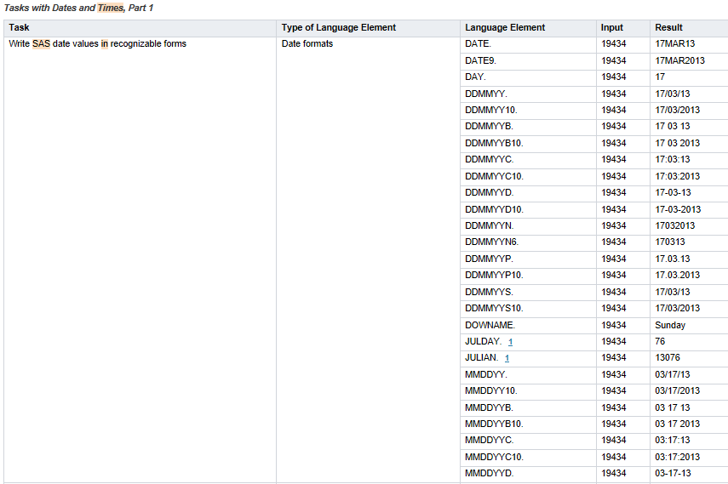

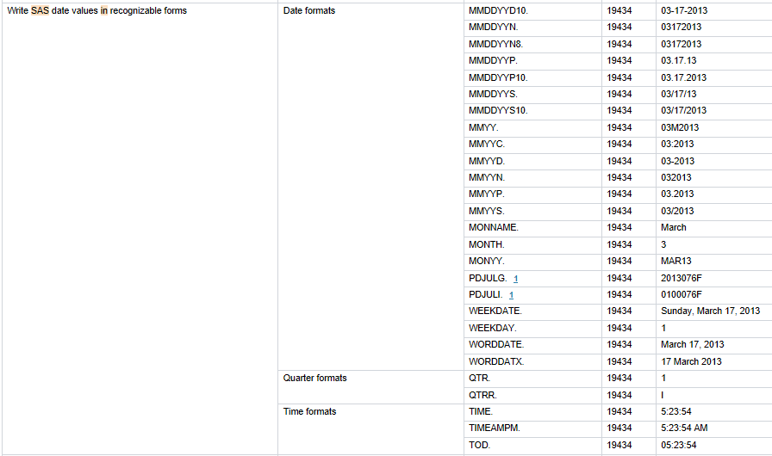

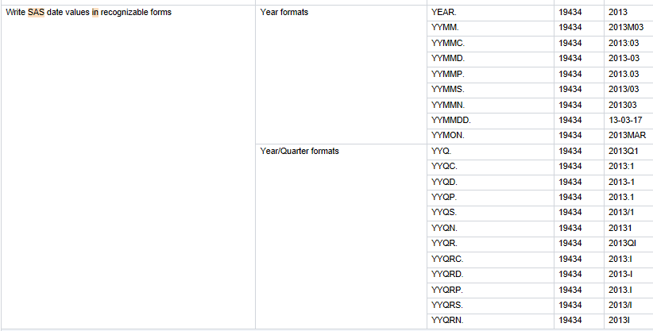

d)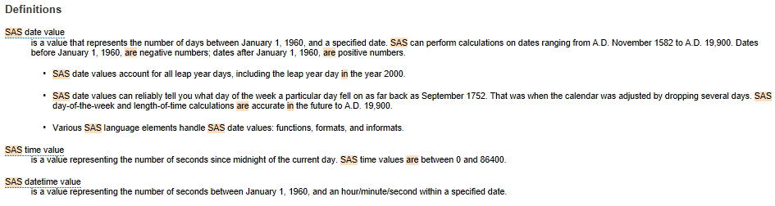

a sas time value represents the number of seconds since midnight of the current day.

A sas datetime value represents the number of seconds between January 1,1960, and the hour/minute/second within a specific value.

4)A,b,c,d.

LIBNAME ORION2"C:\Users\User\Desktop\D\P1 DATA & PROG (1)\P1 DATA";

**PROC** **CONTENTS** DATA=ORION2._ALL_ NODS;

**RUN**;

%let path=C:\Users\User\Desktop\D\P1 DATA & PROG (1)\P1 DATA;

libname orion2 "C:\Users\User\Desktop\D\P1 DATA & PROG (1)\P1 DATA";

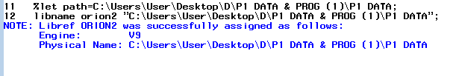

**E.**

**proc** **contents** data=orion2._all_nods;

**run**;

libname orion2 clear;

f) 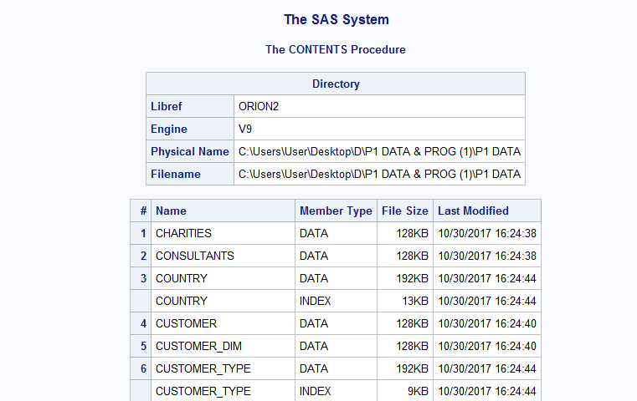

G.

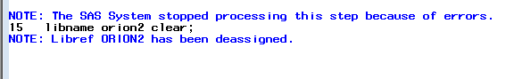

5)A.B.C.

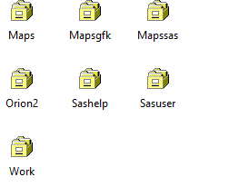

d)

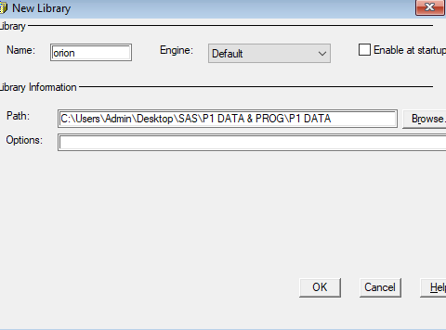

E.

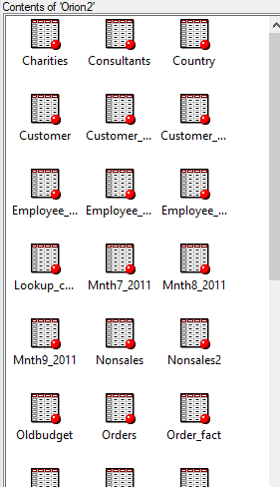

F.

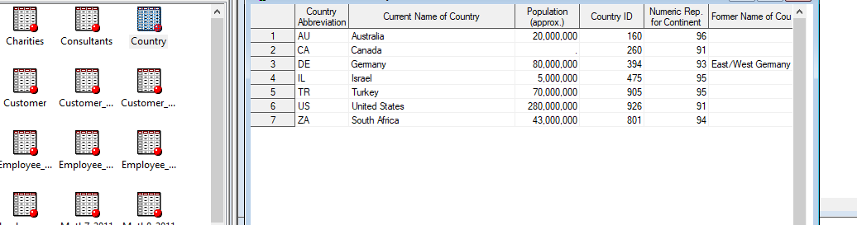

G.

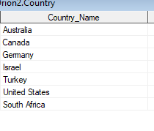

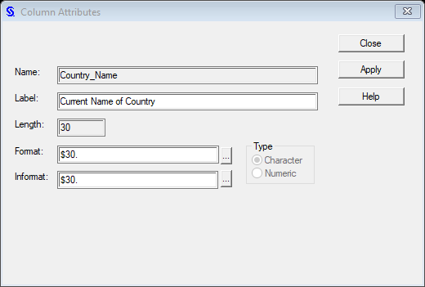

6.a)

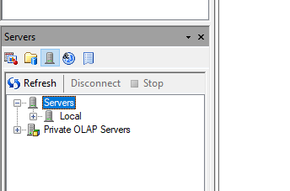

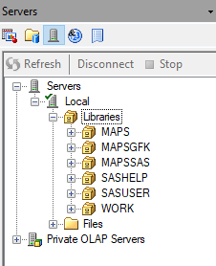

b)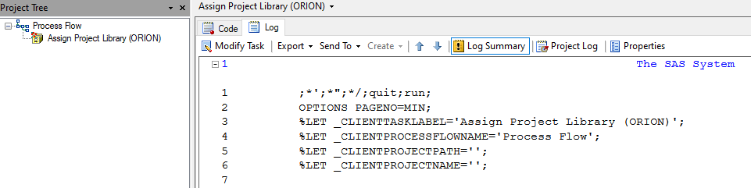

c)

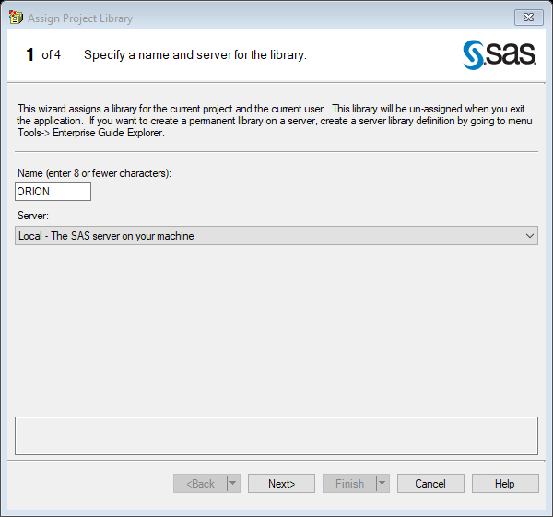

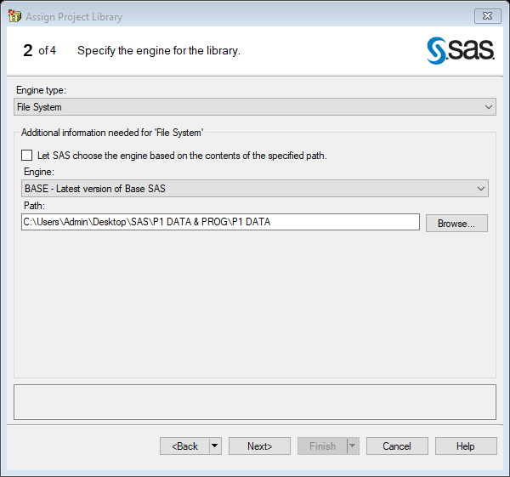

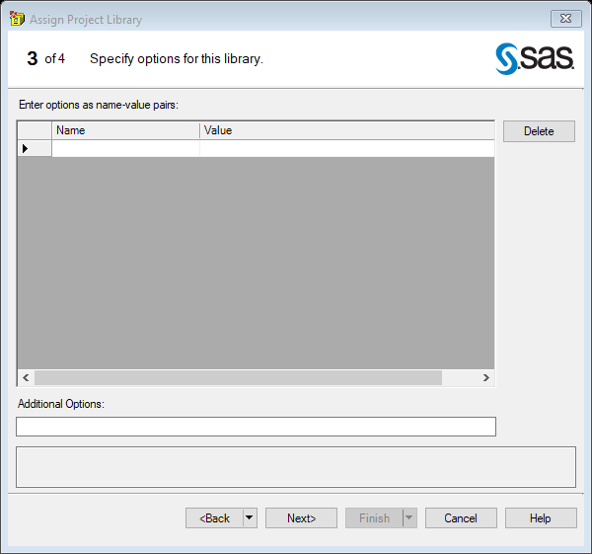

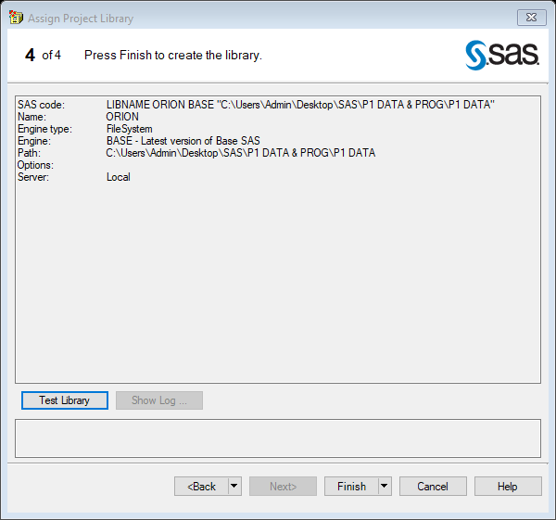

d)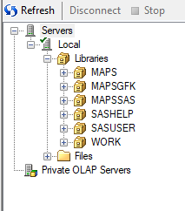

e) 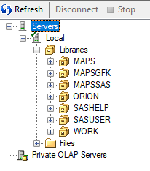

f) 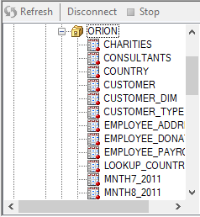

g)

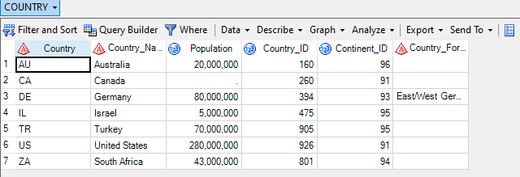

h)

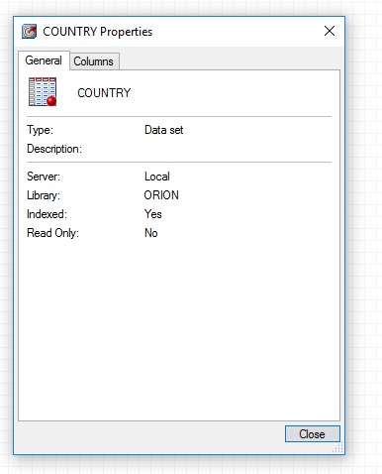 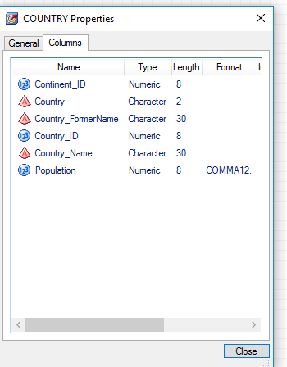

7. a) click new library

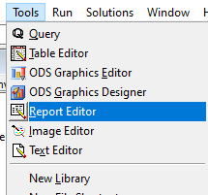

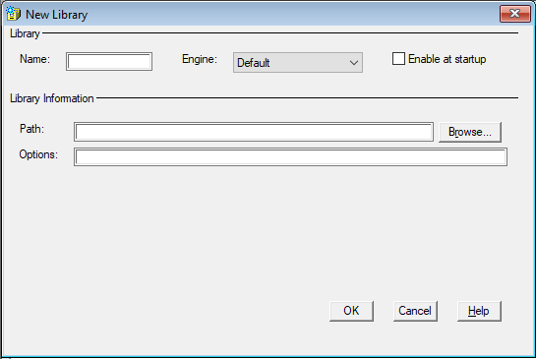

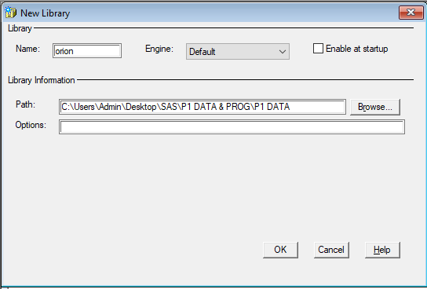

c)click ok.

d) 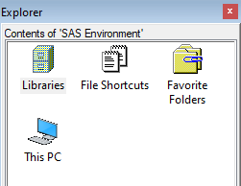

e)

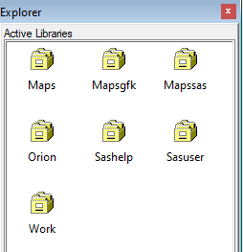

f) 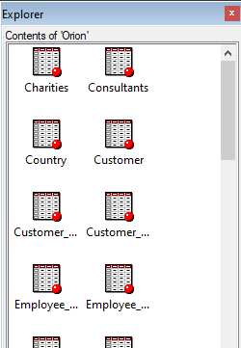

g) 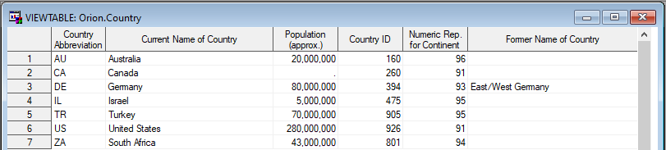

h) 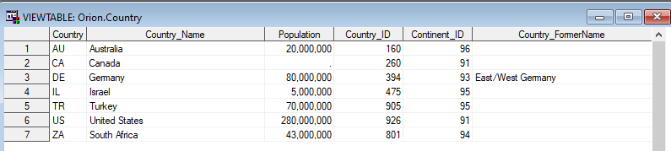

i)

